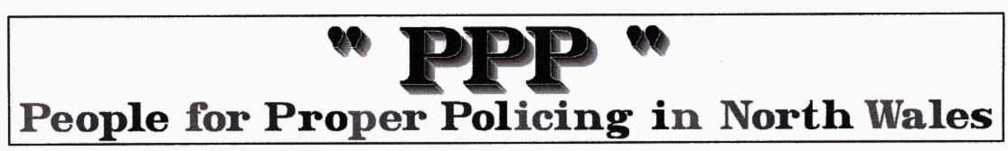

Oliver Cromwell's speech dismissing Parliament on 20th April 1653

“... It is high time for me to put an end to your sitting in this place, which you have dishonoured by your contempt of all virtue, and defiled by your practice of every vice; ye are a factious crew, and enemies to all good government; ye are a pack of mercenary wretches, and would like Esau sell your country for a mess of pottage, and like Judas betray your God for a few pieces of money.

“Is there a single virtue now remaining amongst you? Is there one vice you do not possess? Ye have no more religion than my horse; gold is your God; which of you have not barter'd your conscience for bribes? Is there a man amongst you that has the least care for the good of the Commonwealth?

“Ye sordid prostitutes, have you not defil'd this sacred place, and turn'd the Lord's temple into a den of thieves by your immoral principles and wicked practices? Ye are grown intolerably odious to the whole nation; you were deputed here by the people to get grievances redress'd; your country therefore calls upon me to cleanse the Augean Stable, by putting a final period to your iniquitous proceedings, and which by God's help and the strength He has given me, I now come to do.

“I command ye, therefore, upon the peril of your lives, to depart immediately out of this place! Take away that shining bauble there, and lock up the doors. You have sat here too long for the good you do. In the name of God, go!”

For some background to the circumstances surrounding this event go to ..
http://www.british-civil-wars.co.uk/glossary/long-parliament.htm

The PPP comments … all we say is “if the cap fits wear it! whether it be plain cloth, a silly grey wig or ermin lined”

We now have the unelected Prince of Darkness smarming all over our TV screens as he pretends to run the economy. They even asked the ex pornographer Campbell to take a peerage so he can take over the lying machine before the next election. His title for Blair was the Prime minister's communications chief, a ‘skill’ he learnt under Robert Maxwell

